Name Bilal Abid Abbasi

Class 1 semester

Pf lab assignment

Programs using while loop.
Iqra University
Islamabad Campus Fall Semester 2025

ASSIGNMENT # 01
Course Code: CSC 131 | Course Title: Programming Fundamental
Teacher’s Name: Mr. Ilyas Badshah | Total Marks: 10
Deadline: 10 Jan 2026 | Time: 11 59 pm

1. Sum of all integers from 1 to 100 (while loop)

Program
#include <iostream>
using namespace std;

int main () {
int i = 1, sum = 0;

while (i <= 100) {
sum = sum + i;
i++;
}

cout << "Sum of numbers from 1 to 100 = " << sum;
return 0;
}
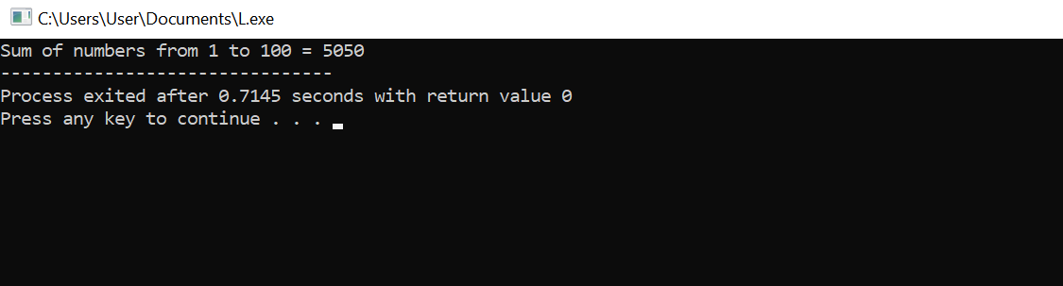

2. Factorial of a number (while loop)

Program
#include <iostream>
using namespace std;

int main () {
int n;
long long fact = 1;

cout << "Enter a number: ";
cin >> n;

while (n > 0) {
fact = fact * n;
n--;
}

cout << "Factorial = " << fact;
return 0;
}
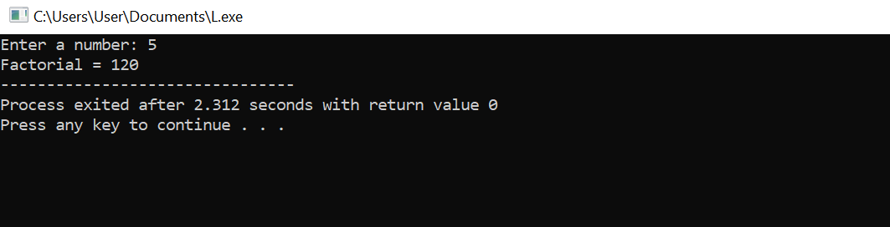

3. Count digits in a number (do-while loop)

Program
#include <iostream>
using namespace std;

int main () {
int num, count = 0;

cout << "Enter a positive integer: ";
cin >> num;

do {
num = num / 10;
count++;
} while (num > 0);

cout << "Number of digits = " << count;
return 0;
}
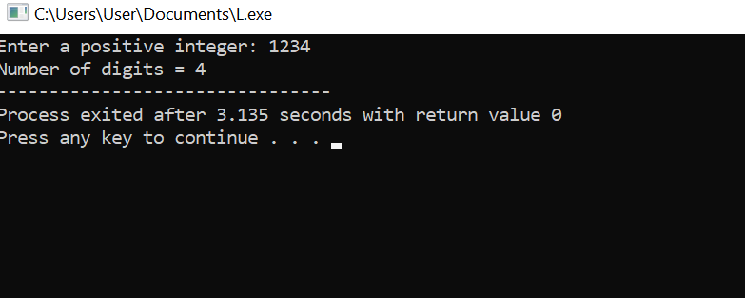

4. Largest number among N numbers

Program
#include <iostream>
using namespace std;

int main() {
int n, num, largest;

cout << "Enter the count of numbers: ";
cin >> n;

cout << "Enter " << n << " numbers: ";
cin >> largest;

for (int i = 1; i < n; i++) {
cin >> num;
if (num > largest) {
largest = num;
}
}

cout << "Largest number = " << largest;
return 0;
}
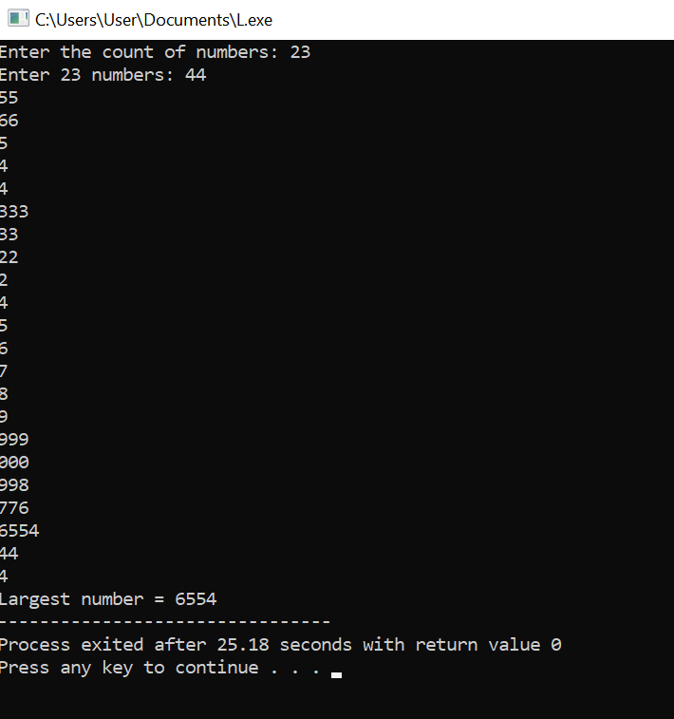

5. Numbers divisible by both 3 and 5 (1 to 100)

Program
#include <iostream>
using namespace std;

int main() {
cout << "Numbers divisible by both 3 and 5 are:\n";

for (int i = 1; i <= 100; i++) {
if (i % 3 == 0 && i % 5 == 0) {
cout << i << " ";
}
}
return 0;
}
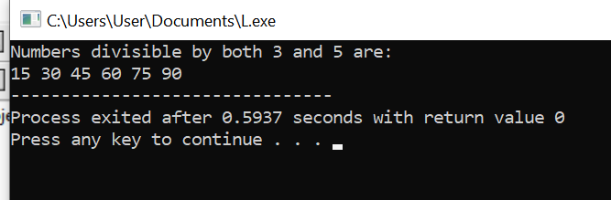

Iqra University
Islamabad Campus Fall Semester 2025

ASSIGNMENT # 02
Course Code: CSC 131 | Course Title: Programming Fundamental
Teacher’s Name: Mr. Ilyas Badshah | Total Marks: 10
Deadline: 10 Jan 2026 | Time: 11 59 pm

C++ Program: Functions for Area and Perimeter
#include <iostream>
#include <cmath> // for M_PI
using namespace std;

// ----------------- Rectangle -----------------
double calculateRectangleArea(double length, double width) {
return length * width;
}

double calculateRectanglePerimeter(double length, double width) {
return 2 * (length + width);
}

// ----------------- Triangle -----------------
double calculateTriangleArea(double base, double height) {
return 0.5 * base * height;
}

double calculateTrianglePerimeter(double side1, double side2, double side3) {
return side1 + side2 + side3;
}

// ----------------- Circle -----------------
double calculateCircleArea(double radius) {
return M_PI * radius * radius;
}

double calculateCircleCircumference(double radius) {
return 2 * M_PI * radius;
}

// ----------------- Cube -----------------
double calculateCubeSurfaceArea(double side) {
return 6 * side * side;
}

double calculateCubeVolume(double side) {
return side * side * side;
}

// ----------------- Parallelogram -----------------
double calculateParallelogramArea(double base, double height) {
return base * height;
}

double calculateParallelogramPerimeter(double side1, double side2) {
return 2 * (side1 + side2);
}

// ----------------- Main Function -----------------
int main() {
// Rectangle
double length = 5, width = 3;
cout << "Rectangle Area = " << calculateRectangleArea(length, width) << endl;
cout << "Rectangle Perimeter = " << calculateRectanglePerimeter(length, width) << endl;

// Triangle
double base = 4, height = 3, side1 = 4, side2 = 5, side3 = 6;
cout << "Triangle Area = " << calculateTriangleArea(base, height) << endl;
cout << "Triangle Perimeter = " << calculateTrianglePerimeter(side1, side2, side3) << endl;

// Circle
double radius = 7;
cout << "Circle Area = " << calculateCircleArea(radius) << endl;
cout << "Circle Circumference = " << calculateCircleCircumference(radius) << endl;

// Cube
double side = 3;
cout << "Cube Surface Area = " << calculateCubeSurfaceArea(side) << endl;
cout << "Cube Volume = " << calculateCubeVolume(side) << endl;

// Parallelogram
double pBase = 6, pHeight = 4, pSide1 = 6, pSide2 = 5;
cout << "Parallelogram Area = " << calculateParallelogramArea(pBase, pHeight) << endl;
cout << "Parallelogram Perimeter = " << calculateParallelogramPerimeter(pSide1, pSide2) << endl;

return 0;
